TECHNICAL REPORT ON STUDENT INDUSTRIAL WORK EXPERIENCE SCHEME (SIWES)

HELD AT
ARCHIC CONSTRUCTION LIMITED,
YOLA, ADAMAWA STATE

FROM: 6TH OCTOBER, 2023
TO: 29TH JANUARY, 2024

BY
VICTOR LINUS
(SE/ARC/ND/22/023)

SUBMITTED TO THE DEPARTMENT OF ARCHITECTURAL TECHNOLOGY, FEDERAL POLYTECHNIC MUBI, IN PARTIAL FULFILLMENT OF THE REQUIREMENT FOR THE AWARD OF NATIONAL DIPLOMA (ND) IN ARCHITECTURAL TECHNOLOGY

MARCH, 2024

DECLARATION
This is to declare that I, VICTOR LINUS with registration number SE/ARC/ND/22/023 undertook my four months SIWES at ARCHIC CONSTRUCTION LIMITED, YOLA, ADAMAWA STATE and have acquired all the experience compiled in this report in the course of my SIWES.

……………………………….. ……………………………
VICTOR LINUS Sign/Date

CERTIFICATION
This is to certify that this report compiled by VICTOR LINUS (SE/ARC/ND/22/023) meets the regulations of governing the award of National Diploma (ND) of the Federal Polytechnic Mubi, and is approved by:

………………………………. …………………………
Name of Supervisor Date
Departmental Supervisor

………………………………. …………………………
Arc. Dangana T. Halla Date
Departmental SIWES Coordinator

…………………………………. …………………………
Arc. Hussaini Haruna Date
Head of Department
DEDICATION
I dedicate this technical report to my parents, my sisters and colleagues and to all those that supported me throughout me industrial training.

ACKNOWLEDGEMENTS
First of all, my sincere appreciation goes to Almighty God and salutation to my prophet.
I wish to thank all staff of Architectural Technology department in Federal Polytechnic, Mubi.
My appreciation goes to my beloved parent for the motivation, prayers and financial support towards my SIWES exercise.
My special thanks go to my beloved brothers and sisters for all their care and support throughout my industrial training.
I want to also thank my colleagues and others; I really appreciate your efforts.

TABLE OF CONTENTS
TITLE PAGE………………………………………………………………… i
DECLARATION…………………………………………………………….. ii
CERTIFICATION………………………………...………….………………. iii
DEDICATION………….………………………..………….……………….. iv
ACKNOWLEDGEMENT……………………………………….……………v
TABLE OF CONTENTS…………………………………..…….……………vi
ABSTRACT……………………………………………………….…………. viii
CHAPTER ONE
1.0 Introduction……………………………………………………………….1
1.1 Aims and Objectives of SIWES………………………………………….. 1
1.2 Brief history of SIWES……………………………………………………2
1.3 Significance of SIWES………………………………………..…..……… 3
CHAPTER TWO
  - Brief History of Organization………………………..……........................ 4
2.2 Organogram……..………………………………………..……................. 4
CHAPTER THREE
3.0 Description of work experience……..………………………………….5
3.1 Setting out……..………………………………………..……............... 5
3.2 Site clearance…..………………………………………..……............. 5
3.3 Excavation of foundation……..……………………………………….. 5
3.4 Tiles Fixing………….…..…………………………………………….. 8
3.5 Working Drawing on site ……………………………………………... 10
CHAPTER FOUR
4.0 Summary, Recommendation and Conclusion…………………………. 14

4.1 Problems observed during my program……………………………….. 14
4.2 Summary……..…………………………………………………………14
4.3 Conclusion……..……………………………………………………….15
4.4 Recommendations……..………………………………………………. 15
Reference. ………………………………………..……................................... 16

ABSTRACT
The report summarises the result of work done during my SIWES experience, the technical report consists of four chapters, which comprises of introduction, history and criteria’s of SIWES in chapter one followed by their aims and objectives, historical background, organizational structure of the organization in chapter two, while chapter three consist of the work actually carried out during the SIWES programme and lastly chapter four consist of the summary, conclusions and recommendation.

CHAPTER ONE
1.0 INTRODUCTION
The acronym (SIWES) meaning “Student Industrial Work Experience Scheme” is a skill training designed to expose and prepare student in institution of higher for industrial working situation they may likely meet after graduation. The scheme is meant to train student on the method of work and the experience needed in handling the equipment and machines may not to be available in their institution. The scheme is financed by the Federal Government and operators through Industrial Training Fund (ITF), Ogwo, (2001) and operates with National University Commission (NUC), National Board of Technical Education (NABTEC), and National Commission for College of Education (NCCE) and industries. However, SIWES also expose the student to many practical works which the institution did not treat in details without plastering what the institution taught theoretically into practical. A point from academic obtained. SIWES assist the student to understand the nature of his/her work in future.

1.1 Aim and objective of SIWES
ITF initiates SIWES with the sole aim of: Exposing student with the practical experience related to the theoretical knowledge acquired in school. Bridging the gap between theoretical learning and practical work situation.
- To make industries/organization to have confidence in the abilities and capacities of the graduates. SIWES helps the industries to evaluate the prospective employees and give feedback to the institution.
- It helps the student to gain work and also have experience and confidence as a result if successful completion of a given job assigned to them.
- To enlist and strengthen the employers’ involvement in the institution activities and in the entire educational process of preparing the student for meaningful and productive employment into industries.
- It provides an avenue for student in the Nigerian University and Polytechnics to acquire industrial skill and experience in their course of study.
- Development for greater understanding in other people and proffers skills in human relations.

1.2 Brief history of SIWES and ITF in Nigeria
It was said by Dr. Azikiwe Nnamdi, the one president of Nigeria that the practice of work but they all have the same goal that they all want to achieve in countries like china. They established within the premises of institution to provide real life situation, lack of practical skill of locally trained engineers and technologies. the chine way and condition of SIWES is that all institution must give student real life working experience in industrial works. Lecturers are involved in the industrial activities rendering constant services. So, all these countries have their own way of conducting the scheme but all lye on the same goal. And in Nigeria, the history of SIWES can be traced by the history of IITF which is the backbone of SIWES. ITF was established in 1974 under degree of 47 of 1971. It was a body established by the Federal Government of Nigeria and was given responsibility of training indigenous Nigerians. The establishment of the body became necessary due to high demand of Nigeria to take up the vacant positions created in various sector of the economy after the colonial masters have departed. Therefore, the Federal Government discovered that it is easier to train students that are skilled in school to be trained and meet up with gaps in the Nigerian economy and a scheme was established to care for such training and it was named Student Industrial Work Experience Scheme (SIWES). In 1973, the national board of technical education (NBTE) made it compulsory for all the polytechnic students, be it federal or state.

1.3 Significance of SIWES to students
Principles taught in the classroom are vein forced given concrete applications on the industrial assignment and students is able to see the relevance of their students which increase their motivation. It helps in given students the knowledge on the types of work to do after his/her graduation. SIWES given students opportunity for a change of environment as they move their institution to the place of attachment which changes the routine types of environment to a word of work. It helps in connecting the institution and the industrial their relationship the introduction of SIWES.

CHAPTER TWO
2.1 BRIEF HISTORY OF ARCHIC CONSTRUCTION LIMITED
Archic Construction Limited in Yola, Adamawa State, had humble beginnings rooted in the ambition of its founder, Ibrahim Musa. Established in 2005, the company emerged in response to the growing demand for reliable construction services in the region. Ibrahim, with a background in civil engineering and a passion for community development, envisioned a company that would not only excel in construction but also contribute to the socio-economic growth of Adamawa State.
Archic Construction Limited in Yola, Adamawa State, provides a wide array of services encompassing architectural design, civil engineering, construction, project management, renovation, infrastructure development, sustainable building solutions, consultancy, interior fit-out, and landscaping. Their architectural design services include conceptualization, drafting, 3D modeling, and interior design. They specialize in civil engineering, offering structural and foundation design, as well as site planning and road construction.

2.2 ORGANIZATIONAL CHART
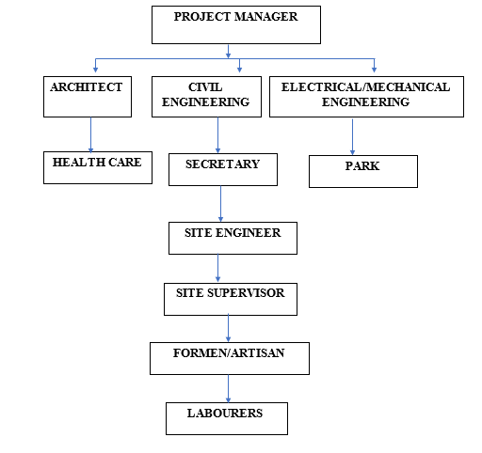

Figure 1: Organogram

CHAPTER THREE
3.0 DESCRIPTION OF WORK EXPERIENCE
This initiate, coordinates, supervise, and control matters such as funding, hiring key personnel, contracting and arranging for distributors. This also is involved throughout all phases of the process from the development to completion of the production.
3.1 OFFICE EXPERIENCE
This part is a summary of lessons learnt in the office and on different projects carried out during my SIWES training.
In the office basically, I was able to work on different projects and designs that were sketched by my supervising Architects, before being given to me to draft on the computer, while the ones revised are already on the system which had been previously worked on by a staff of the firm.
3.2 ARCHITECTURAL WORKS
I discovered that there was no room for mistakes no matter the cost because a minor mistake in design stage could or would lead to a major disaster during or after the construction stage so, all possible errors in the design stage must be eliminated. I also learnt that there were regulations and laws guiding every aspect of a building design and its construction, which I summarized in the following:
- The minimum set back from the road to the building line is 6 meters, while from the center of the road to the building line is 9 meters.
- Architectural works must be interactive and necessary specifications must also reflect in the designs apart from the schedules.
- The structural stability of a design at the inception stage.
The architects must take int consideration the structural aspect of the building, which gives the structural engineer a framework to work with and at the end of the project.

3.3 WORKING DRAWING/CONSTRUCTION DOCUMENT
The working drawing phases of construction document describes in graphics form, all of the essential of the work to be done: location, size, arrangement and details of the project. Since the successful and timely execution of these document can be equated closely with an office’s financial success, architect constantly search for more efficient ways to produce construction documents. Regardless of the method of preparation, it is extremely important that the document is accurate, consistent, complete and understandable. This requires through quality control including constant review and cross-checking of all documents. In addition, effective coordination of consultant drawings is essential to avoid conflicts and interference in the construction of the architect designs and documents the integrated results
3.4 SITE EXPERIENCE
This part deals with the knowledge gained by me from the construction site visited during my SIWES programme where I was exposed to various projects. I spent my industrial training with LSDPC. The company is focused on civil, electrical mechanical and survey building engineering project with several engineers handling different project across the country.
Also, site inspection is done regularly to make sure the building is going on well and correction are made on site to the contractor, which I was always present during inspections.
Also, the technical meeting is also held once in a week involving the consultants, contractors, also the sub-contractors, of which I was always attending with my boss, issues and the growth of the projects are being discussed.
Also, monthly site meetings are done once in a month, involving client representatives, consultant, contractor’s representatives. Where the clients come to check the progress of work done and issues affecting the progress of the work.

3.5 PHYSICAL MEASURES OF BUILDING COMPONENTS AND EXTERNAL WORKS
The major work I did during my industrial attachment was measurement of building works and external works. The building components can be found in the main building generator house, gate posts, gate house, sewage treatment house, underground water tank, sewage lift pit etc. the external works can be found in the driveways and parking lots, entrance culverts, retaining walls etc.
3.5.1 OBSERVING AND NOTING LABOUR
I observed and noted labor outputs for different trades which includes: painting, wall and floor tilling, interlocking pavement stones application, steel grill and plaster board ceiling and lifting and installation of steel roof trusses above the third-floor painting application, spandex trowel sprinkle-tan, I observed and noted the following parameters: name of paint, number of drum used, time of paint application, time at the end of paint application, numbers of painters and square meters covered. In tile laying: i.e. ceramics floor and wall titles, I observed and noted the following parameters; name of tiles, number of tilers and laborers and the square meter covered per day.
I also supervised cement and sand mix for floor scree ding which is done to prepare the floor for receiving tiles and to get all part of the floor on the same level. The difference between this mix and mortar is that it is low in water to cement ratio. It serves as backing for floor tiles. The mix ratio for cement and sand adopted for floor scree ding was 1:6 i.e. 1 head pan of cement to 6 head pan of sharp sand or one bag of cement to 12 head pans of sharp sand.
3.5.2 Z-purline
I work on using Z purlins on the rafter that are designed to form the roof wall, is used in form of the iron rafter between the roofing sheet and also give support to the rafter, Z-purline are used in construction of iron rafter that hold and give adequate support so that it can give adequate and maintain for a long time.
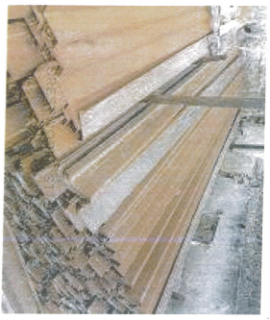
Z-purline gives support to the rafter that hold the middle of the rafter. It also support the roofing sheet, it also gives good adequate support in-between the rafter that hold the purlins and roofing sheets.
Plate 1: Z-purlins
Source: Author’s work, 2023

JOIN PURLINE: A longitudinal member in a roof frame, usually for supporting common rafters or the like between the plate and the ridge.
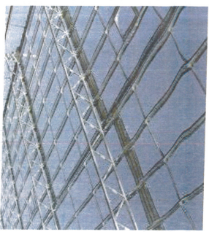
Plate 2: Join iron Z-purlins on the building
Source: Author’s work, 2023

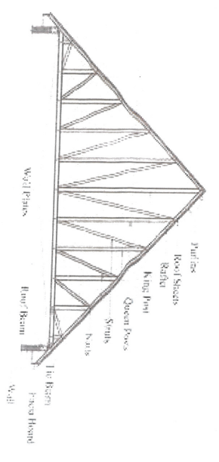
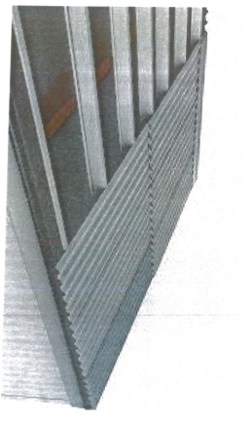
Plate 3: Lying and fixing of roofing sheet
Source: Author’s work, 2023

Figure 2: Structure of iron rafter on top of the building
Source: Author’s work, 2023

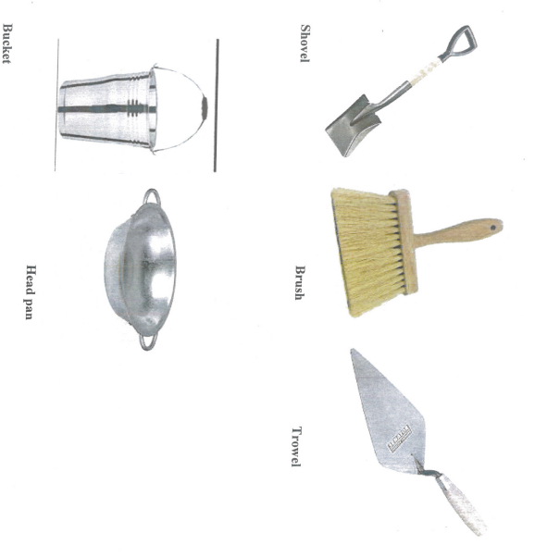

Plate 4: Hand tools used on site
Source: Author’s work, 2023

CHAPTER FOUR
4.0 SUMMARY, RECOMMENDATION AND CONCLUTION

4.1 PROBLEMS OBSERVED DURING MY PROGRAM
- The time frame set for the program is too short as some of the aspects of the program where not completed.
- Lack of Financial support from the company to aid transportation to and from training.
- Attentions are not given to the IT students by the workers it is learn if you want to learn or ask if you want to know.

4.2 SUMMARY
One would state that the discipline is the training of the mind and body towards effective performance. The Students Industrial Work Experience Scheme (SIWES) is more or less achieving this fit. As it further builds on the theoretical classrooms leaving a practical approach of the industry and commerce to supply of finished goods and services. This program has enabled the participating students to be practically involved in the day-by-day activities of the industries and commerce.
Emphasis in the observation of industrial safety rules and regulations, time critical operation and proper man-hand management, quality cortices, etc. are daily activity objective. All those aimed at the production of marketable goods and services in the world of work.
However, to consolidate on the gains of this Industrial Training Fund (ITF) higher institution coordinator on SIWES program should be allowed making some suggestion and recommendation.

4.3 CONCLUSION
SIWES programme is very vital student especially undergraduates, because I come to see the SIWES programme provide an application of the theoretical knowledge learned by student in school to practical or real work situation. Also, it is a medium where student from different higher institutions and department come together sharing idea there, by promoting an avenue for learning and them work.
4.4 RECOMMENDATIONS
Having being exposed to a bit of what entail working in an individual related to my course of study under SIWES programme I wish to make this recommendation
- Higher instruction of learning especially either institution and universities should establish link with comprise and establishment so as to provide space for student on industrial attachment, with the option of gaining employment in future, by doing so, it will go a long way in alleviating suffering and difficulties encountered by student in securing place for individual attachment.
- Student should put money as the primary aim of going SIWES programme, there is more to learn than Bain allowance.

REFERENCE
Chudley, R. (2005). Construction technology volume 2. Pearson Prentice Hall, New York.
Edward, B. (2003). The Effect of SIWES on a student, Federal Ministry of Works, Lagos. Nigeria.
Francis, K. (2012). Building Construction Illustration. (Fourth Edition). Wiley Publisher. ISBN-10: ‎ 9788126535637.
Obande, M. (1990). Blocklaying and Concreting, 2nd Edition. Pearson Education Limited, Harlow United Kingdom. ISBN13 9780582025417.

